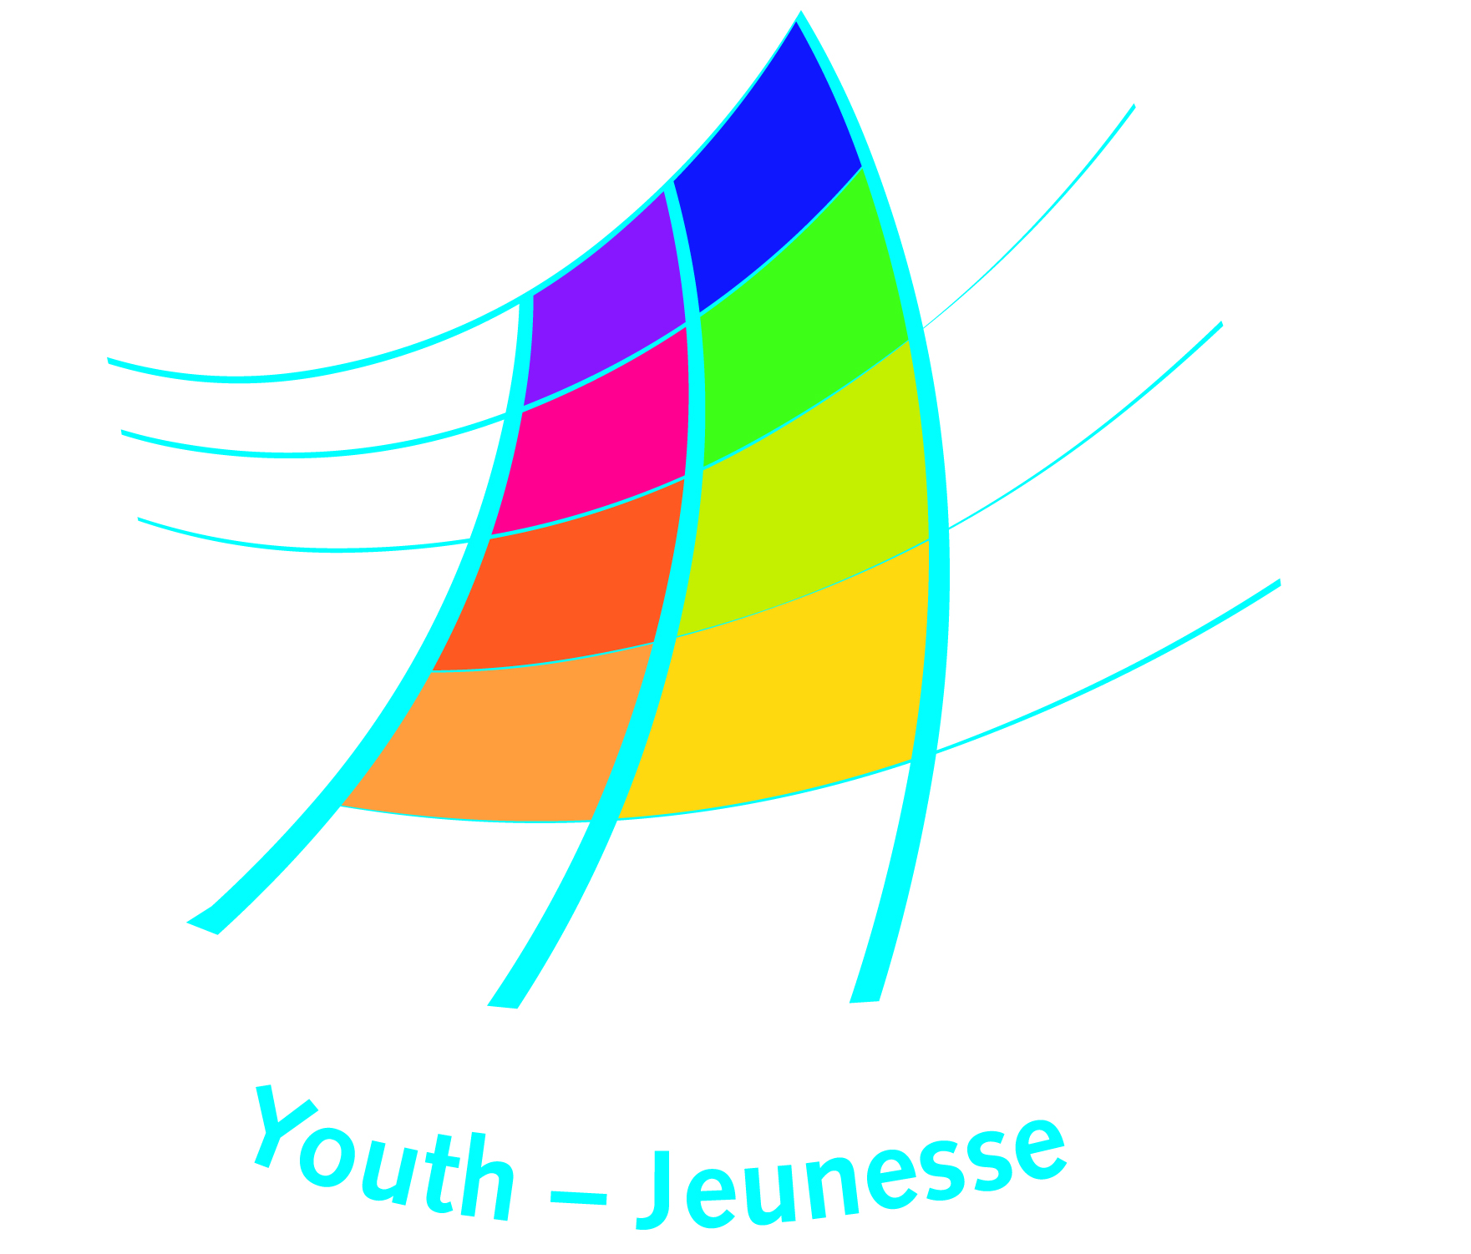
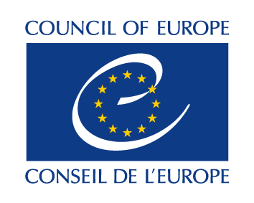

DDCP-YD EYD (2018) 42 Strasbourg, 28 March 2018

IS THIS IT?...

Evaluation Conference of the
No Hate Speech Movement youth campaign

Looking Back, Moving Forward

European Youth Centre, Strasbourg, 10-12 April 2018

InfoPack

Dear Friend,
We are looking forward to seeing you soon at the Evaluation Conference of the No Hate Speech Movement youth campaign. This document should help you to get prepared accordingly. Please read carefully and start preparing.
Best wishes, and see you soon in Strasbourg!

Objectives and Programme of the Conference
The Evaluation Conference will be a moment for campaigners to look back and forward, to celebrate achievements and to learn for future action. Hate speech does not stop with the closing of the campaign: online human rights issues are as important as ever and education for human rights, offline and online, remains a global need for children and youth across Europe and beyond. This is not all. We have set up a web page where you can find the updated information for the conference, including the programme. Please check this regularly and further promote the page.
The conference will celebrate, review and consolidate the achievements, successful practices and policy interventions of the No Hate Speech Movement youth campaign. Its objectives are to:
- give recognition and visibility to the achievements of the campaign
- reflect on the findings of the external evaluation of the youth campaign for 2016-2017 and to review and validate its recommendations
- reflect on emerging developments in hate speech and human rights online and consider future measures to be taken in light of what has been learned
- propose guidelines for member states and the Council of Europe on how to strengthen the role of young people in combatting hate speech through policy and practice
- identify and propose future actions by national campaigns, partners and activists who are continuing the No Hate Speech Movement.

Working languages
The working languages at the conference will be English and French with simultaneous interpretation. Be sure to equip yourself with necessary support such as dictionaries or digital translators, should you feel that you will need them.

Technical information

The conference will be held at the European Youth Centre Strasbourg (EYCS). The address is:

European Youth Centre

30, rue Pierre de Coubertin

F - 67000 Strasbourg

FRANCE

Tel: + 33 3 88 41 23 00 (reception is open 24/24 hours).

Here, you can find information on how to arrive to the EYCS

Access needs / specific requirements

If you have any special requirements (mobility, auditory, dietary, allergies, etc.), please inform us immediately by contacting Estelle (Estelle.Glessinger@coe.int) if you have not already done so.

Accommodation
With this info pack you received information about your accommodation. If you didn’t receive this information, please contact Estelle (Estelle.Glessinger@coe.int). Please check your emails before contacting Estelle!

Registration and travel reimbursement
Please register and submit your travel reimbursement upon arrival to avoid unnecessary delays in processing your claim. A desk to register for the conference and submitting travel reimbursement claim is open as follows:
- Monday 9 April, 16.00 – 20.30 at the 5th floor of the EYCS
- Tuesday 10 April, 9.00 – 13.30 and 18.00 – 20.00 in the dining area, ground floor of the EYCS
- Wednesday 11 April, 8.00 – 9.15 in the dining area, ground floor of the EYCS

Please make sure to have all relevant travel tickets, invoices and proof or payment with you to submit with the reimbursement form. Please consult the checklist sent together with this info pack and the rules for travel sent to you together with the invitation letter.
Any reimbursement forms that are not submitted before the end of the conference will not be taken into consideration and therefore you will not receive reimbursement for your travel expenses.

Live streaming and social media
Most plenary sessions from the conference will be live-streamed on the Facebook page of the No Hate Speech movement. Please check the page regularly and subscribe to the live-streaming the week before the conference. Please help promote the link for the live-streaming with your colleagues, activists, organisations etc. so they can also follow some of the discussions and conclusions on the conference.
If you do not want photos / videos taken of you, or that you appear on the live-streamed please notify us by sending an email to Estelle (Estelle.Glessinger@coe.int) before noon (12h00) on Friday 6 April. We will make sure you don’t appear on photos/videos/live-stream.

How to prepare
Some of the elements in the programme would need preparation from your side, please check the information below carefully.

Registration for Thematic working groups
Please register for one of the working groups in the afternoon of the second day (11 April) by 6April. The working group titled “This was it” looks further into the achievements and shortcomings of the campaign with the aim that we learn from these experiences and prepare proposals for the future work on hate speech. There were 9 themes identified based on the evaluation report and the registration forms received:
- Human Rights Education – Learning from practices in education to counter and prevent hate speech
- Media and Hate Speech – literacy, journalist training, guidelines and codes of conduct
- Campaigning with and for groups targeted by hate speech – from thematic approaches to coalitions to counter hate speech and protecting human rights for all
- Sexism and Gender Equality online – the campaign’s contribution now and in the future
- Youth work - Youth initiated, led and implemented activities at grass-roots level
- Online Safety for and by youth - Approaches and practices to encourage online safe behaviour of children and youth
- The Internet and Hate Speech - Engaging with Internet businesses and others for effective addressing online hate speech
- Policy and legislative action on hate speech - political and society support for legislative and policy measures on hate speech and discrimination
- We CAN! - CAN We? - from learning to using counter and alternative narratives to Hate Speech as a campaign tool.

You can find a short presentation and register for the working groups on the Conference webpage. Please submit your first and second proposal before 6 April (Friday) at noon.

Welcome spaces
Upon arrival you will find welcome spaces in 5 different corners of the youth centre which are set up for you to reconnect with other participants and start sharing and discussing between each other. The welcome spaces include among others:
- The conference conclusions: Here you can find the draft conference conclusions for you to comment upon, provide proposals for changes, additions or simply agree/disagree and add reflections. This space will be available until the evening of Day 2 of the conference.
- The exhibition space: Here you can exhibit new or updated leaflets, pictures, posters from your campaign. You can start sharing what was happening within the campaign, get inspired and further network with each other the minute you arrive. To help develop the exhibition and give visibility to the actions you organised in your national campaign, with partners or activists since March 2013, we ask you to:
  - prepare and bring one poster (40X60cm or 60X80cm) which highlights your main achievements since 2013. Be creative! You can highlight:
    - events/training activities you organised in your city/region/country
    - international events you took part in
    - tools you created, online or offline
    - partnerships launched with other countries
    - famous people who supported the campaign
    - educational activities in schools, youth camps, etc.
Feel free to add brief testimonials about your experience, what the NHSM means to you, quotes or statements of young people or activists who took part in the activity.
  - In addition to the posters please bring any kind of promotional material that you would like to share with other conference participants of the conference.

Moving forward
On day 3 we will have working groups on the continuation of the movement by national campaigns, partners, activists and education professionals. In order to prepare for these working groups please consult with your colleagues and people you worked with during the campaign about their motivation and interest to remain active in fighting for Human Rights online. Also, please identify any specific proposals, questions or concerns that you would like to discuss with others.

